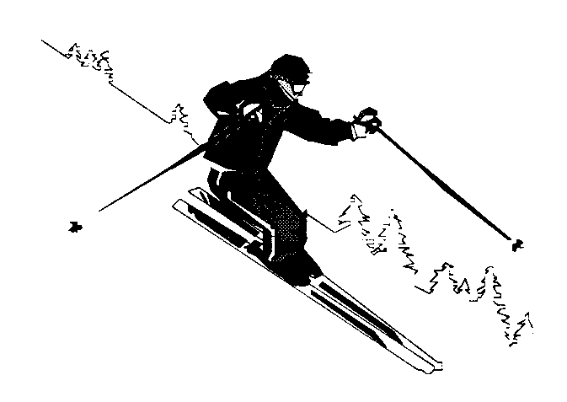 |  | ACCOMMODATION  BOOKING FORM  (Please read the booking guidelines below prior to completing this form) |  | Desert Alpine Club Inc.  C/o: Joanne Leggett  P.O.Box 60,  Mangaweka, 4746
Name(s): (Please name everyone in your party)
Address:
Town/City:
Contact : | Mobile: |  | Email

Date In: |  | Total Bunks/Nights:  (NB: Bunks can comfortably fit two)
Date Out:
Estimated Time of Arrival: |  | Do you have 4WD vehicle?

 | Rate/Night | Number | No of Nights | SubTotal

Members
Senior | $32.00
Intermediate (12-17 incl) | $27.00
Junior (5-11 incl) | $17.00
Under 5’s | Free

Non-Members
Senior Non-Member | $57.00
Int Non-Member (12-17 incl) | $47.00
Junior Non-Member (5-11 incl) | $37.00
Under 5’s | Free
 |  |  | TOTAL

PAYMENT METHODS:
1. Direct Credit - 020192 0018386 00. If using this method, please include your family name in the reference field. Email this form to joanne.p.leggett@gmail.com
2. Cheque - Attach your cheque to this form and send to The Booking Officer.
Desert Alpine Club Inc.
C/o: Joanne Leggett
P.O.Box 60,
Mangaweka, 4746

3. All accomodation must be paid for prior to your stay, otherwise your booking will not be confirmed.
4. Booking confirmation will be emailed once this form and payment has been received by the Booking Officer.

BOOKING GUIDELINES

1. Pencil bookings can be made by phone. Bookings will be confirmed once the booking form and payment has been received by the Booking Officer. You can either email or post your booking forms.

2. For information or to make a booking, phone or text JOANNE LEGGETT at home on 06 3825567, or 027 3805094 or e-mail joanne.p.leggett@gmail.com In season phone 06 8258118.

3. Cancellations can be made by phoning, texting or emailing Joanne no later than 9pm, four working days prior to any accommodation booking date. Requests for refund of lodge fees cancelled within the four days must be made in writing to the committee.

4. Ski Squad accommodation must be booked and paid for prior to each squad weekend.

5. People taking their vehicles up the mountain road are advised that only four-wheel-drive vehicles that have chains fitted, and a front towing eye or hook, will be offered assistance beyond the base camp car park. Everybody must ring the lodge at Tukino (06 387 6294) from Turangi or Waiouru so the lodge officer is aware you are on your way (please ask to speak to the lodge officer at Desert Alpine). Cell phone reception is very limited on the road to the lodge. Should any other drivers attempt to reach Tukino, they do so at their own risk.

REMEMBER: For your own safety and health getting to Tukino, dress warmly for the trip (ski clothing, boots, gloves and hat recommended) before you commence up the mountain road. You and your passengers can get very cold on the journey to the lodge especially if you have any problems. In case you need assistance, please pack all essential items into one pack, taking only what you can carry. All other goodies can be collected when the sun is up and the weather improves.

5. Please take a pillow slip (pillows & blankets are provided), sleeping bag and torch.

7. Dinner is not included in the first night of your stay.

8. Please make sure that all your ski equipment is clearly marked for you to identify your gear. All hire equipment looks the same so you must have some means of identifying what is yours. Skis, boots and poles are left in the wet entry or drying room and on a busy day there can be some huge mix-ups.

9. Check out time is 3pm on your day of departure. Please remove all of your gear from the bunk rooms before this time. You are welcome to use the lodge facilities after 3pm but remember other people will be moving in. The lodge is to be clean and tidy before the changeover. The lodge officer will inform you of the duties to be carried out before leaving.

10. Please take home with you any empty cans and bottles that you take to the lodge.

11. Plain food is supplied for all meals. Please bring anything extra you may require i.e. fruit juice, muesli bars, drinking snacks, chips and dip, etc.

12. If the Lodge is left dirty or damage has been sustained, there may be a surcharge to cover expenses.

