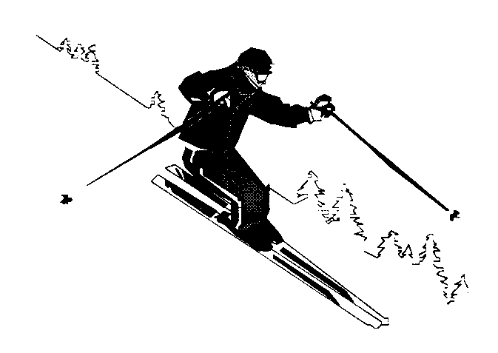

**Desert Alpine Club Inc.**

**c/o The Treasurer**

**1595 Waingaro Rd**

**R.D.1**

**Ngaruawahia 3793**

**MEMBERSHIP APPLICATION**

2014

(Please complete one for each person)

**Applicant to complete this section**

I, the undersigned, wish to become a member of the Desert Alpine Club Inc and, if approved, agree to adhere to the rules and by-laws of the Club, to which alterations may be made at any time.

Mr/Mrs/Ms Surname First Names

|  |
| --- |
|  |

Address:

|  |
| --- |
|  |
|  |

Phone: Mob:

|  |
| --- |
|  |

Email: DOB if under 18:

|  |
| --- |
|  |

**Please tick the appropriate fee boxes**

**Annual Subscriptions for 2014:**

SENIOR...............................……....... ❄ $75

JUNIOR/INTERMEDIATE........…... ❄ $40 (below the age of 18yrs as at 1st April )

FAMILY.......................................….. ❄ $200

STUDENT/PENTIONER………….. ❄ $50 (student ID required)



## NOTES:

* **Applications for membership are only accepted from the 1st January to the 31st May.**
* **It is a pre-requisite of membership approval that you attend a working bee prior to submitting your application.**
* Children under 5 are free, but please complete an application form.
* Juniors are aged 5 to 11 years inclusive. Intermediates are aged from 12 to 17 years inclusive. Senior applies when a person turns 18 prior to the 1st April in the membership/subscription year.
* Family rate applies for a family of two adults with 2 or more juniors or intermediates of the same family.
* There is no joining fee – just the yearly subscription/working bee

**SIGNATURE: DATE:**

|  |
| --- |
|  |

**Nominator and Seconder to complete this Section**

We, the undersigned, being members of the Desert Alpine Club Inc. for more than 2 years, do propose the above person for membership.

**Nominator: ___________________________ Seconder: ______________________________________**

**Signed: _______________________________ Signed: _______________________________________**

### For office use only

Application Received ___/___/___ Received by: ______________________________________

Approved by Committee: ___/___/___

Receipt: ___/___/___ Receipt No: ________________________________________